
SCHOOL OF ECONOMICS AND BUSINESS
May 31, 2025
Portfolio Optimisation and Risk Allocation (PORA 9X1)
Group Mini Research Project Submission
Portfolio Selection and Optimization

Aphelele Nombila, Tshepo Mpande, Siphamandla Dhlamini, Boikanyo Rankapole, Mufaro M. Ruzive,
Flavien Fokou Noumbissie

Contents
1. INTRODUCTION 3
2. LITERATURE REVIEW 4
2.1 Introduction 4
2.2 Stock portfolio 4
2.3 Traditional Optimisation Techniques 5
2.4 Empirical studies and research gap motivations 6
2.5 Conclusion 7
3. METHODOLOGY 8
3.1 Global Minimum Variance 8
3.2 Mean- CVaR 9
3.3 Equal-Risk Contribution 9
3.4. MACHINE LEARNING 10
4. DATA DESCRIPTION 13
4.1 Introduction 13
4.2 Data Collection and Preparation Methodology 13
4.3 Data Cleaning and Transformation Processes 13
4.4 Range Analysis (Maximum - Minimum Returns) – Identifying the Riskiest Stocks 14
4.5 Mean Returns (Average Performance) – Which Stocks Performed Best? 15
4.6 Standard Deviation (Volatility) – Measuring Consistency of Returns 15
4.6 Risk adjusted performance (Modified Sharpe Ratio) 17
5. PRELIMINARY DATA ANALYSIS 18
5.1 Univariate Stylized Facts Analysis of JSE Equity Returns 18
5.2 Preliminary Analysis (Multivariate) 30
6. EMPIRICAL RESULTS AND DISCUSSION 34
7. CONCLUSION AND RECOMMENDATION 49
8. REFERENCES 50

1. INTRODUCTION

Constructing an optimal investment portfolio represents a cornerstone challenge for investors aiming to navigate the intricate dynamics of financial markets while effectively balancing risk and return (Kisiel and Gorse, 2021). In this endeavour, we employ a multifaceted approach, integrating machine learning methodologies with established portfolio optimization techniques, including Mean-CVaR, Global minimum variance, Equal-Risk Concentration, and Entropy pooling, to discern their efficacy in risk mitigation and return maximization across diverse market conditions( Li, Xie and Seco, 2025). The increasing complexity inherent in financial data, coupled with the limitations of conventional models like Markowitz's mean-variance framework, has spurred heightened interest in alternative optimization strategies, notably data-driven machine learning techniques(Sutiene, et al, 2024). Our analysis leverages individual asset evaluations conducted by team members to assess these methodologies within a unified asset portfolio, thereby providing a comprehensive perspective on their comparative strengths and weaknesses (Wang and Yu, 2021). Machine learning methodologies can double the performance of regression-based strategies by identifying nonlinear predictor interactions (Gu, Kelly and Xiu, 2020).
This study aims to examine the role of machine learning techniques in enhancing traditional financial models and to identify the most reliable method for constructing optimal portfolios under conditions of market uncertainty. The analysis focuses on a selection of key assets, namely SASOL, Naspers, MTN, Shoprite, AngloGold, FirstRand, Anglo American, Standard Bank, Absa, and Gold Fields, which were chosen to ensure sectoral diversification while maintaining a balanced representation of the market. Initially, the study also included Discovery and Capitec; however, these were subsequently excluded to prevent overexposure to the financial sector, thereby refining the dataset to ten stocks for a more robust and representative analysis. By leveraging machine learning approaches, this research seeks to improve the accuracy and adaptability of conventional portfolio optimization techniques, particularly in volatile and unpredictable financial environments.
This study adopts a structured approach to evaluate portfolio optimization techniques. The analysis commences with a comprehensive review of existing literature on portfolio optimization, identifying key limitations that inform the methodological framework. Subsequently, the dataset and selected optimization techniques are examined in detail, providing the foundation for empirical testing. A rigorous comparison of model performance is conducted using established risk-return metrics to assess relative efficacy. The study concludes by synthesizing findings into practical recommendations for investors and proposing avenues for further research. Through this systematic investigation, the research bridges theoretical finance with practical portfolio management, offering evidence-based insights for contemporary investment strategies.

2. LITERATURE REVIEW

Introduction
Stocks are a type of financial security that represents ownership in a company and a claim on part of its assets and profits. To manage risk effectively, investors often adopt diversified investment strategies by holding different stocks across various sectors. These approaches helps control risk and improve expected returns. The term stock portfolio refers to a group of stocks held together for the purpose of diversification and risk management. To minimize potential losses and enhance returns, investors have developed a range of quantitative techniques aimed at optimizing portfolio performance. Portfolio optimization has thus become a key component of financial decision-making, originating from Markowitz's Modern Portfolio Theory (1952), which introduced the mean-variance framework. Over time, technical advancements have addressed the limitations of variance as a risk measure by incorporating alternative approaches such as Conditional Value-at-Risk (CVaR), Equal Risk Contribution (ERC), and more recently, machine learning (ML) techniques. In this chapter, we will classify the stocks used in our optimization case study; discuss performance expectations of similar stocks. We explore the evolution and application of optimisation methods, their methodological innovations, and relevance in emerging markets such as South Africa. We will elaborate on the importance of portfolio optimisation. Finally, we will examine the empirical evidence and theoretical contributions from previous literature on stocks and portfolio optimization.

Stock portfolio
In this study, we will focus on a portfolio made of 10 stocks spread across different sectors. The various sectors are where our portfolio stocks have been selected in the South Africa industry are: Financial and insurance, mining, telecommunication, energy and retail. In the energy sector, Sasol Ltd (SOL.JO) stands out as a major player in chemicals and fuel production, heavily influenced by global oil and gas prices. Naspers Ltd (NPN.JO) represents the technology and consumer services sector. It is a multinational with significant investments in global internet companies. From the telecommunications sector, MTN Group (MTN.JO) brings exposure to mobile and data services across Africa and the Middle East, albeit with political and regulatory risks. Shoprite Holdings (SHP.JO) represents the consumer staples sector, which is Africa’s largest food retailer, known for its stable revenues and defensive characteristics. The portfolio features a strong representation from the financial sector, including FirstRand (FSR.JO), Standard Bank (SBK.JO), and Absa Group (ABG.JO). All of them offer diversified retail and corporate banking services across Africa. In the mining sector, Anglo American (AGL.JO) provides exposure to diversified mineral resources operations globally, while AngloGold Ashanti (ANG.JO) and Gold Fields (GFI.JO) offer leverage to gold prices through their extensive gold mining operations.

    - Importance of diversified portfolio and portfolio optimisation

These classifications highlight the portfolio’s balance between growth, defensive, and cyclical stocks, enhancing diversification and providing a broad foundation for risk-controlled return optimisation. Having such a diverse portfolio is essential for effective risk management and long-term wealth generation. Diversification across sectors helps reduce exposure to sector-specific downturns, smoothens returns, and improves the risk-return trade-off. For example, losses in cyclical sectors like mining or energy may be offset by gains in more stable sectors like consumer staples or financials. Additionally, by combining growth-oriented stocks with defensive and income-generating stocks, investors can build resilience against market volatility while positioning the portfolio for consistent performance across varying economic cycles. This strategic blend is a cornerstone of Modern Portfolio Theory (Markowitz, 1952) and a key principle in constructing robust, optimized investment portfolios.
The process to efficiently allocate stocks to a portfolio is known as portfolio optimisation. Portfolio optimisation is a fundamental aspect of modern investment strategy, aiming to allocate assets in a manner that maximizes expected return for a given level of risk or minimises risk for a given level of return. In other words, portfolio optimisation helps investors make rational decisions under uncertainty by quantitatively balancing trade-offs between risk and return. It is important in particularly volatile markets, where unstructured asset selection may expose investors to excessive risk or underperformance.

    - Portfolio expectation
Performance expectations for such a portfolio, when properly optimized—are promising. Nationally, diversified JSE portfolios have historically achieved better Sharpe ratios and downside protection than sector-concentrated portfolios. Internationally, when these South African stocks are included in global emerging market portfolios, they provide exposure to resource-driven growth, financial innovation, and demographic trends, making them attractive for international investors seeking both return enhancement and diversification benefits. Hence, both theory and empirical evidence suggest that constructing and maintaining a well-diversified stock portfolio like this not only reduces unsystematic risk but also enhances long-term performance, both within South Africa and in a global investment context.

Traditional Optimisation Techniques
    - Mean-Variance and Global Minimum Variance (GMV)
The Markowitz mean-variance model laid the groundwork for modern portfolio theory, emphasizing a trade-off between return and risk (Markowitz, 1952). The Global Minimum Variance (GMV) portfolio, a derivative of this model, aims to minimise portfolio variance without considering expected returns, making it robust against estimation errors in return forecasts (DeMiguel et al., 2009). However, GMV is not without problems, it is sensitive to outliers in the covariance matrix and can lead to concentrated positions in low-volatility assets, reducing diversification (Merton, 1980).

    - Downside Risk Optimization: Mean-CVaR
To address the shortcomings of variance as a risk metric, Rockafellar and Uryasev (2000) introduced Conditional Value-at-Risk (CVaR), which captures tail risk beyond a certain confidence level. The mean-CVaR model replaces variance with CVaR in the optimisation process, allowing for more accurate modelling of extreme losses. Nevertheless, mean-CVaR models are highly sensitive to errors in return estimation and tail distribution assumptions. Nakagawa (2021) emphasizes that small changes in input parameters can cause large shifts in optimal portfolio weights, making the model unstable in practice.

    - Risk-Parity Approaches: Equal Risk Contribution (ERC)
Equal Risk Contribution (ERC), also known as the most-diversified or risk-parity portfolio, was developed to overcome the limitations of return-based optimisation. Instead of maximising return or minimizing variance, ERC portfolios aim to allocate risk equally among assets (Maillard et al., 2010). This method avoids relying on return estimates, making it less susceptible to estimation errors (Roncalli, 2014). The ERC’s exclusion of expected returns can lead to suboptimal performance when return differentials are large (Xu et al., 2023). Its computation also becomes complex when incorporating real-world constraints like transaction costs and turnover limits (Spinu, 2013).

    - Machine Learning Techniques in Portfolio Optimization
Machine learning (ML) has recently emerged as a powerful tool in asset allocation, offering a data-driven alternative to traditional models. Unlike classical approaches, ML algorithms can detect complex, nonlinear relationships in financial data without relying on strict distributional assumptions (Fan et al., 2020). One commonly used Machine Learning method is the Principal Component Analysis also known as PCA. It is a statistical technique used primarily for dimensionality reduction, feature extraction, and data visualisation. PCA transforms a large set of correlated variables into a smaller set of uncorrelated variables called principal components, while retaining as much of the original dataset's information as possible. Nevertheless, the use of ML techniques comes with challenges. They often suffer from over fitting, lack interpretability, and require extensive computational resources (De Prado, 2018). In markets with limited high-frequency data such as the JSE, these issues can impair generalizability.

2.4 Empirical studies and research gap motivations

2.4.1 Empirical studies
Empirical studies in both developed and emerging markets provide strong support for such diversification. For instance, Clarke, de Silva, and Thorley (2006) found that minimum-variance portfolios constructed with sector and asset diversification consistently outperformed the market on a risk-adjusted basis. In the South African context, Van Rensburg and Robertson (2003) demonstrated that sector diversification significantly reduced portfolio volatility on the JSE, especially during periods of macroeconomic uncertainty. Furthermore, international comparative studies (e.g., Bekaert& Harvey, 1995) highlight that emerging markets like South Africa offer higher average returns due to risk premiums, but also higher volatility, making diversification especially critical. More recent studies have incorporated machine learning and non-traditional risk measures (such as Conditional Value-at-Risk and Expected Shortfall) to improve portfolio selection, particularly in volatile or non-normal return environments. Several studies have validated GMV's performance in practical settings. Chopra and Ziemba (1993) highlighted its robustness compared to return-dependent methods, especially under return estimation errors. In emerging markets like South Africa, where reliable return forecasts are harder to obtain, GMV's reliance solely on covariance estimates makes it appealing (Van Rensburg& Robertson, 2003).Empirical studies demonstrate that mean-CVaR portfolios often outperform mean-variance portfolios under non-normal return distributions and during market stress (Agarwal &Naik, 2004; Yao et al., 2013). In emerging markets characterized by frequent volatility spikes such as the JSE, this model offers better downside protection (Mhlanga et al., 2022).Perrin and Roncalli (2020) and Mausser & Romanko (2014) show that ERC delivers superior out-of-sample performance and better diversification, especially in volatile or concentrated markets. The JSE, being resourced and finance-heavily, benefits from ERC’s equal risk allocation as it avoids overexposure to dominant sectors (Georgantas et al., 2024).Studies like Gu, Kelly, and Xiu (2020) demonstrate that machine learning models such as LASSO, decision trees, and neural networks significantly enhance return forecasts and portfolio efficiency. In contexts like South Africa's JSE, where markets are volatile and macroeconomic shocks are frequent, ML offers flexibility and adaptability. A number of comparative studies (e.g., DeMiguel et al., 2009; Maillard et al., 2010) indicate that models requiring fewer return assumptions (ERC, GMV) often outperform those that depend on precise forecasts (Mean-CVaR, ML) in real-world settings. This is particularly true for emerging markets where data quality and frequency are often limited. Machine learning methods, while promising, are best used as supplements to traditional models rather than standalone optimizers, unless data conditions are ideal. On the JSE, hybrid models that combine ML-driven forecasting with ERC or GMV optimization have shown empirical success (Perrin &Roncalli, 2020).

2.4.2 Research Gap and Motivation
This study aims to bridge that gap by empirically applying and comparing these four optimization techniques using data from the Johannesburg Stock Exchange. The goal is to provide actionable insights on the most effective portfolio construction strategies in emerging and volatile market environments. Although numerous studies have explored these techniques independently, few have conducted a head-to-head comparison of GMV, Mean-CVaR, ERC, and ML models under a unified framework and in the context of emerging markets like South Africa. There is limited research evaluating their relative robustness, diversification efficiency, and adaptability to market-specific constraints.

2.5 Conclusion
In this chapter, we laid down an understanding of stocks and the definition of stock portfolio with their importance. We also dwelled on the relevance of portfolio optimisation in efficiently helping in the choice of stocks and their allocations. The various optimisation techniques to be used in this study have been introduced. The portfolio optimisation methods will range from rigid, return-based frameworks to more flexible, risk- and data-driven models. While each technique has its merits, their effectiveness depends heavily on market structure, data availability, and investor priorities. For emerging markets like South Africa, methods that minimize dependence on unstable return forecasts such as ERC and GMV offer greater robustness. However, integrating these with machine learning tools can further enhance adaptability and forecasting precision. This study positions itself within this evolving landscape to identify optimal portfolio strategies for real-world application in volatile environments. We concluded the chapter with some empirical works around stock; stock optimisation and techniques used for efficient stock allocation.

3. METHODOLOGY
This section outlines the portfolio optimization techniques applied for this research, namely Global Minimum Variance, Mean Conditional Value at Risk (CVaR), Equal-Risk Concentration (ERC), and Machine Learning (ML). Each method is selected based on its theoretical soundness and practical relevance in risk management and decision-making under uncertainty.

3.1 Global Minimum Variance
The GMV portfolio is the portfolio with the lowest possible risk for a given set of assets, without any constraints on expected returns. One of GMV advantages is that, unlike the Markowitz efficient frontier, which requires expected returns, GMV portfolio only depends on the covariance matrix. An investment in the GMV portfolio often yields better out-of-sample results than does an investment in the tangency portfolio (Kempf & Memmel, 2006).The mathematical formulation of this model is as follows:
Objective: $\min_{w}{{ W}^{T}\sum{W}}$
Subject to: $W^{T}1=1 (fully invested constraint)$

Where W is the vector of portfolio weights ($w_{1},w_{2},...,w_{N})$, Σ is the covariance matrix of asset returns.
When an investor invests in a GMV portfolio, the lowest achievable variance is w' Σw, given the restriction w'=1, where 1= (1... 1)' represents the p-dimensional vector of ones and W is the vector of portfolio weights. The following provides the weights of the GMV portfolio.
$$W_{GMV}=\frac{Σ^{-1}1}{1^{T}Σ^{-1}1}$$
The steps to solving this problem include computing the inverse of the covariance matrix ($Σ^{-1})$, multiply $Σ^{-1}$ by a vector of 1s and lastly, normalize the resulting vector so that weights sum to 1.
In this technique, no expected return input is required, distinguishing it from the Markowitz efficient frontier technique which requires expected returns. By definition this technique has the smallest risk possible among all possible portfolios and by its nature it is sensitive to covariance error estimation
One major limitation of GMV is that it is very sensitive to estimation errors in the covariance matrix, especially when there are many assets. The estimation error in the sample covariance matrix can lead to extreme and unstable portfolio weights in minimum-variance strategies (Ledoit and Wolf, 2003).

3.2 Mean- CVaR
The main objective of the Mean-CVaR in portfolio management is to minimize the coherent risk measure while achieving a target expected return. The Mean-CVaR is an extension of the mean-variance portfolio optimization by Markowitz (1952). Rockafellar and Uraysev (2000) modified the mean-variance portfolio model by replacing the variance with the CVaR. The mean-CVaR is modelled by combining the objective of risk minimisation and minimum expected return constraint. An advantage of the Mean-CVaR is that, unlike the VaR, CVaR is sub additive and convex. Mean-CVaR is tail risk focused; it accounts for extreme losses beyond the VaR. The model can be mathematically depicted in the following manner:
$Minimize_{w,ξ}$ ${CVaR}_{∝}\left(L\left(W\right)\right)$
Subject to $E\left[W^{T}R\right]≥μ_{0,}$
$$\sum_{i=1}^{n}{w_{i}=1,}$$
$w_{i}≥0$(No short-selling, (optional))
Where:
R is the asset returns vector,$∝$ is the confidence interval,$L(W)=-W^{T}R$ is the portfolio loss, and the $ξ$is an auxiliary variable used in CVaR computation.
Rockafellar and Uraysev (2002) found that a mean-CVaR portfolio optimization may be overly conservative, sacrificing returns to reduce risk in tail events. This conservatism arises because CVaR, by design, focuses on the expected loss beyond the VaR threshold, leading to portfolios that prioritize extreme-risk mitigation over return maximization. While this is beneficial for downside protection, it may result in suboptimal performance in stable markets.

3.3 Equal-Risk Contribution
ERC is a portfolio optimization technique that aims to allocate assets in such a way that the risk contribution of each asset to the overall portfolio is equal. An ERC portfolio takes into account single and combined risk contribution of each asset (Millard et al., 2011). In contrast to conventional mean-variance optimization, which emphasizes expected returns and variances, ERC concentrates exclusively on the allocation of risk among assets. The risk contribution of an asset, restated in more general terms, can be presented as below:
$C_{i}M_{ω∈Ω}=ω_{i}\frac{∂M_{ω∈Ω}}{∂_{ωi}}$
Where:
$M_{ω∈Ω}$ is the linear homogenous risk measure and $ω_{i}$ is asset ith weight.
The risk measure can be the portfolio’s standard deviation, the value at risk, or the expected shortfall. By Euler’s homogeneity theorem, the total portfolio risk is equal to the sum of the risk contributions as defined in Equation (4).We can express the contributions as a percentage by dividing the risk contributions by the value of $M_{ω∈Ω}$:
${\%C}_{i}M_{ω∈Ω}=\frac{∂M_{ω∈Ω}}{m_{ω∈Ω}}×100$
If we insert portfolio standard deviation formula in place of the risk measure, we get $σ(ω)=\sqrt{ω^{'}\sum{ω}}$where $ω$ is the (N X 1) weight vector and Σ denotes the variance-covariance matrix of asset returns with off-diagonal elements $σ_{ij}$and with $σ_{i}^{2}$theith element on its main diagonal (i.e., thevariance of the returns for the ith asset). The partial derivatives of this standard deviation are given by:
$$\frac{∂σ(ω)}{{∂ω}_{i}}=\frac{ω_{i}σ_{i}^{2}\sum_{i≠j}^{N}{ω_{j}σ_{ij}}}{σ(ω)}$$
These i=1… N partial derivatives are proportional to the ith row of ${(\sum{ω})}_{i}$and hence the ERC portfolio with long-only and budget constraint problem can be stated as:
$$P_{ERC}:ω_{i}{\left(\sum{ω}\right)}_{i}=ω_{j}{\left(\sum{ω}\right)}_{j},∀i,j, \\ 0≤ω_{i}≤1 ∀ i=1,…,N, \\ ω'1=1$$
One of the ERC’s drawbacks is that it ignores the expected returns. Roncalli (2013) argued that ERC may underperform in bull markets since it ignores the expected return.

3.4. MACHINE LEARNING
In the recent years, ML has gained a lot of attention in portfolio optimization. ML methods are able to model nonlinear and complex relationships in finance, and their application is mainly to improve prediction of future asset returns as well as informing portfolio allocation decisions. For this paper, the main reason for the employment of ML methods is to make more accurate forecasts which will be used as inputs in a mean-variance optimization framework.
Principal Component Analysis (PCA)
Principal Component Analysis (PCA) is an unsupervised machine learning technique used to reduce the dimensionality of financial data while preserving as much variance as possible. The idea behind the PCA for this analysis is to identify the key risk factors driving asset returns and construct a portfolio that is more robust and well diversified. The following are the steps to follow when constructing a PCA.
Step 1: Data collection and preparation
The first step is to select assets to include in the portfolio, collect the historical returns data, calculate the excess return and then standardize (optional) the returns to have a mean of zero and variance of 1.
Step 2: Compute Covariance matrix
The next step is to calculate the sample covariance matrix using the following equation:
$$Σ=(1/(T-1))*(R-μ)'(R-μ)$$
Where T is the number of time periods, $μ$ is the mean returns vector, and ‘denotes matrix transpose.

Step 3: Performing PCA on the Covariance matrix
Eigenvalue decomposition is carried out as below:
$$Σ=⋁⋀⋁'$$
Where $⋀$ is the diagonal matrix and $⋁$ is the matrix of eigenvectors.
After decomposition the next thing is selecting a principal component by retaining the first k components that explain most of the variance using common criteria like the Kaiser criterion, scree plot elbow and the cumulative variance explained. The main output is a set of selected principal components that will be used for portfolio construction.

Step 4: Portfolio construction methodology
There are various approaches to carrying out portfolio optmisation using PCA which will be explained as below
Approach 1: Minimum Variance Portfolio using PCA
- Project returns onto principal components
$$F={RV}_{k}$$
Where $V_{K}$ contains the first k eigenvectors
- Construct factor covariance matrix
$$Σ_F=V_{K}'ΣV_{k}=∧_{k}(diagonal matrix)$$
- Compute minimum variance portfolio weights
$$w=∨_{k}Σ_F^{-1}∨_{k}'1/(1'∨_{k}'1)$$
Where 1 is a vector of ones

Approach 2: Risky Parity using PCA Factors (This is the methodology followed in this report)
- Allocate risk equally to principal components:
- Each PC represents an orthogonal risk factor
- Assign equal risk budget to each retained PC
- Compute weights
$$w=Σ(i=1 to k) (1/λ_{i})∨_{i}∨_{i}'1/k$$

Approach 3: Mean Variance Optimization with PCA
- Estimate expected returns
- Use the PCA factors to predict returns (Fama-MacBeth regression)
- Or Use simple historical mean
- Optimize:
$$max w'μ-(γ/2)w'Σw$$Such that w’1=1
Using the reduced-ranked covariance matrix: $Σ≈∨_{k}∧_{k}∨_{k}'$
Step 5: Evaluate the portfolio
Use out of sample testing to validate the performance on unseen data, analyze the contribution from each principal component, and employ performance metrics like Sharpe ratio, maximum drawdown, portfolio turnover and the diversification ratio.
Just like other techniques, the PCA has some drawbacks. In financial applications, higher-order principal components often capture noise, and excluding them can lead to more robust estimation (Alexander, 2008) like the orthogonal risk factors, noise filtering, dimensional reduction, and robustness. There are other alternatives to use in case the limitations of the PCA outweigh its benefits.

4. DATA DESCRIPTION

4.1 Introduction
This section outlines the methodology for data collection, pre-processing, and initial exploratory analysis of ten major Johannesburg Stock Exchange (JSE)-listed stocks. The analysis focuses on daily price movements from January 1, 2015, to March23, 2025, providing insights into return distributions, volatility characteristics, and risk profiles.

4.2 Data Collection and Preparation Methodology
The research commenced with the systematic retrieval of daily closing prices for ten JSE-listed stocks representing diverse sectors of the South African economy. The selected equities include commodity and resource companies (Sasol, Anglo American, AngloGold Ashanti, and Gold Fields), financial institutions (FirstRand, Standard Bank, and Absa), and consumer/tech firms (Naspers, MTN Group, and Shoprite Holdings).
Data acquisition was performed using the quantmod package in R, which facilitated direct extraction from Yahoo Finance's API. The retrieval process specifically captured adjusted closing prices, accounting for corporate actions such as dividends and stock splits to maintain accuracy in return calculations. The complete dataset spans more than a decade of daily observations, providing sufficient depth for meaningful statistical analysis while encompassing various market conditions, including the COVID-19 pandemic and subsequent recovery period.

4.3 Data Cleaning and Transformation Processes
Following data collection, rigorous cleaning procedures were implemented to ensure data integrity. Missing values were identified and addressed through list wise deletion, as the time-series nature of the data made interpolation inappropriate. This approach maintains the temporal integrity of the series while eliminating potential artefacts from imputation. The cleaned dataset was then merged into a single xts object, with careful attention paid to alignment of dates across all securities.
The transformation from raw prices to returns was executed using discrete (simple) return calculations, chosen for their intuitive interpretation in portfolio analysis. The returns were computed as the percentage change between consecutive closing prices, with the resulting series subjected to another round of missing value checks. This conservative approach to data handling ensures that subsequent analyses are performed on a consistent and reliable dataset.
The cumulative returns plot demonstrates three clear patterns: (1) Commodity stocks (Sasol, AngloGold) show extreme volatility with deep drawdown and sharp recoveries, (2) Financials (Absa, FirstRand) move cyclically with economic conditions, and (3) Defensive stocks (Shoprite, MTN) deliver steadier growth. These visual patterns confirm the statistical findings - high volatility sectors exhibit wider return dispersion while low-volatility stocks maintain more stable trajectories.

Figure 1: Cumulative Returns of JSE Stocks (2015-2025)
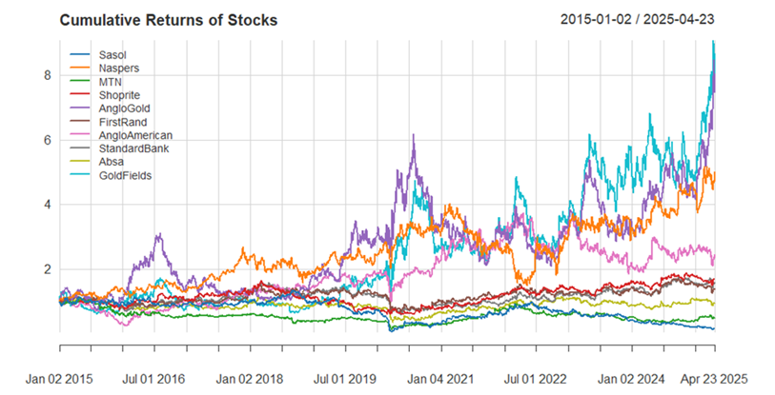
Source: Author’s R computations

4.4 Range Analysis (Maximum - Minimum Returns) – Identifying the Riskiest Stocks
The range (difference between the highest and lowest observed returns) is a simple but effective measure of total risk exposure.
Sasol has the largest range, meaning it exhibits extreme highs and lows in returns this may be due to sensitivity to commodity prices (oil, chemicals) and exposure to geopolitical risks, forex fluctuations, and operational volatility.
Absa, FirstRand, Anglo American, and Goldfields also show wide ranges, indicating high volatility.
- Financial stocks (Absa, FirstRand) may be influenced by interest rate changes and economic cycles.
- Mining stocks (Anglo American, Goldfields) are impacted by commodity price swings.
Shoprite and Naspers have the smallest ranges, suggesting more stable returns. Shoprite (consumer retail) benefits from steady demand (defensive stock). Naspers (tech/investment) may have smoother returns due to diversified holdings.
Interpretation:
- Higher range → Higher risk (potential for large losses or gains).
- Sasol is the riskiest stock in this group, while Shoprite and Naspers are the least risky.

4.5 Mean Returns (Average Performance) – Which Stocks Performed Best?
The mean return serves as a fundamental measure of an asset's average profitability over the observation period, providing critical insight into historical performance trends. Among the analysed securities, Naspers demonstrates superior mean returns, a performance characteristic attributable to its strategic holdings in Tencent and exposure to the high-growth technology sector. Similarly, Shoprite exhibits robust mean returns, reflecting the defensive nature of its consumer staples business model which benefits from consistent household spending patterns regardless of economic conditions.
Conversely, Sasol presents diminished or potentially negative mean returns, a performance pattern that correlates strongly with its exposure to volatile oil prices, significant debt burdens, and ongoing operational challenges within the energy sector. AngloGold Ashanti similarly shows constrained mean returns, mirroring the inherent volatility of precious metal markets and the capital-intensive nature of mining operations.
The financial sector constituents - FirstRand, Standard Bank, and Absa - exhibit moderate mean returns that reflect their position as cyclical performers within the economy. These institutions demonstrate stable earnings capacity tempered by their sensitivity to interest rate fluctuations and broader macroeconomic conditions. The observed mean return distribution across sectors underscores the fundamental relationship between industry characteristics and investment performance, with defensive sectors outperforming commodity-linked businesses over the examined period.
Interpretation:
- Higher mean return → Better historical performance.
- However, high returns often come with high volatility (e.g., Sasol’s extreme swings).
- Risk-adjusted returns (Sharpe Ratio) would help determine if the returns justify the risk.

4.6 Standard Deviation (Volatility) – Measuring Consistency of Returns
Standard deviation (SD) serves as a critical measure of return volatility, quantifying the degree to which an asset's returns deviate from its mean. A higher SD indicates greater price fluctuations and, consequently, higher investment risk. Among the analysed stocks, Sasol, Anglo American, Goldfields, and Absa exhibit the highest standard deviations, reflecting their susceptibility to large price swings driven by commodity price volatility, sector-specific risks, and macroeconomic factors. These securities demonstrate unpredictable return patterns, making them suitable primarily for risk-tolerant investors.
In contrast, Shoprite, Naspers, and MTN display the lowest SD values, indicating more stable and consistent returns. Shoprite’s defensive positioning in consumer retail, Naspers’ diversified tech exposure, and MTN’s resilient telecommunications business contribute to their reduced volatility, making them attractive to risk-averse investors seeking steady performance.
Financial sector stocks, including FirstRand and Standard Bank, exhibit moderate volatility, balancing cyclical sensitivity to interest rates and economic conditions with the inherent stability of well-regulated banking operations. Their intermediate SD values suggest they occupy a middle ground—offering neither the extreme fluctuations of commodity stocks nor the defensive stability of consumer and tech equities. This volatility profile aligns with their role as core holdings in diversified portfolios, providing reasonable returns without excessive risk.

Interpretation:
- High SD → High risk, potential for big gains or losses.
- Low SD → More predictable, but lower returns.
- Investors must decide: Accept higher volatility for higher returns?

Table 1: Combined Insights-Risk vs. Reward
Stock | Mean Return | Standard Deviation | Range | Risk Level
Sasol | Low/Negative | Very High | Largest | Extremely Risky
Anglo American | Moderate | High | Wide | High Risk
Goldfields | Low | High | Wide | High Risk
Absa | Moderate | High | Wide | High Risk
FirstRand | Moderate | Moderate | Medium | Medium Risk
Standard Bank | Moderate | Moderate | Medium | Medium Risk
MTN | Moderate | Low-Moderate | Narrow | Low-Medium Risk
Naspers | High | Low | Narrow | Low Risk
Shoprite | High | Very Low | Smallest | Lowest Risk
AngloGold | High | Low | Narrow | Low Risk
Source: Author’s R computations

4.6 Risk adjusted performance (Modified Sharpe Ratio)
Table 2: Risk Adjusted Performance
Rank | Stock | Modified Sharpe Ratio | Interpretation
1 | AngloGold | 3.3218 | Best performer – High risk-adjusted return
2 | Naspers | 3.2056 | Strong upside potential
3 | Goldfields | 3.0447 | Consistently favourable returns
4 | Anglo American | 1.4949 | Moderate but stable performance
5 | Shoprite | 1.2614 | Acceptable risk-reward trade-off
6 | Standard Bank | 1.0175 | Slightly above neutral (weak positive)
7 | FirstRand | 0.7230 | Marginal positive return
8 | Absa | -0.1757 | Subpar – Slightly negative risk-adjusted return
9 | MTN | -1.0873 | High risk, poor returns
10 | Sasol | -2.2360 | Worst performer – Severe downside risk
Source: Author’s R computations
Top-performing stocks like AngloGold (3.32), Naspers (3.21), and Goldfields (3.04) should be prioritized, as their high ratios indicate strong returns relative to downside risk making them ideal candidates for higher portfolio weights. Conversely, stocks with negative ratios (Sasol: -2.24, MTN: -1.09, Absa: -0.18) fail to adequately compensate for risk and should either be excluded or assigned minimal weights to mitigate tail risk and improve the portfolio’s Conditional Value-at-Risk (CVaR). For diversification, moderate Sharpe stocks such as Anglo American (1.49), Shoprite (1.26), and Standard Bank (1.02) offer a balance, providing stable returns without introducing excessive volatility.
The Modified Sharpe Ratio’s focus on downside risk aligns naturally with CVaR optimization, as both metrics penalize unfavourable deviations. By incorporating these ratios into optimization constraints such as penalizing negative-Sharpe assets the portfolio can achieve a more robust risk-return profile. For further refinement, complement this analysis with historical volatility and CVaR estimates to fine-tune asset weights.

5. PRELIMINARY DATA ANALYSIS

5.1 Univariate Stylized Facts Analysis of JSE Equity Returns
The foundational step in the portfolio selection and optimization process is the preliminary data analysis; this step enables the study to comprehensively understand the underlying characteristics of each asset (Hosseinzadeh, 2023). This step provides essential insights into the statistical properties and empirical behaviour of financial time series. It is fundamental to thoroughly examine the return dynamics of each asset to understand their distributional characteristics, dependencies, and volatility patterns, before any modelling or optimization can be carried out. In this section of the study, we extract the return series for each stock and analyse a series of well-established stylized facts associated with asset returns (Sherkar, and Sen, 2023). These include tests for time-varying volatility, distributional asymmetry, and temporal dependence, which refers to features that deviate from the classical assumptions of independent and identically distributed (i.i.d), normal returns.
Test for Autocorrelation
In financial time series, particularly daily returns, we often assume that returns follow the classical assumption of independent and identical distribution to accommodate models like Capital Asset Pricing Model, Markowitz or Black-Scholes, however, financial return series often exhibit autocorrelation (serial dependence) especially in volatility. To evaluate this process, the study will employ the Ljung-Box test, a statistical test tool to check whether autocorrelations in a time series differ from zero. In simple terms it tests whether the data are independently distributed (no serial correlation) or whether there is evidence of autocorrelation.
Hypothesis
- Null Hypothesis ($H_{0}$)= No autocorrelation
- Alternative Hypothesis (($H_{1}$)= Autocorrelation

Summary of Results and Interpretation
Company | $X^{2}$ Stat | P-Value | Decision | Conclusion
Sasol | 150.88 | < 2.2e-16 | Reject H₀ | Sig autocorrelation
Naspers | 1.311 | 0.003397 | Reject H₀ | Sig autocorrelation
MTN | 40.280 | 0.004604 | Reject H₀ | Sig autocorrelation
Shoprite | 25.525 | 0.1821 | Fail to reject H₀ | No autocorrelation
AngloGold | 24.130 | 0.2368 | Fail to reject H₀ | No autocorrelation
FirstRand | 41.521 | 0.003192 | Reject H₀ | Sig autocorrelation
Anglo American | 38.076 | 0.008669 | Reject H₀ | Sig autocorrelation
Standard Bank | 28.935 | 0.08905 | Fail to reject H₀ | No autocorrelation
Absa | 39.885 | 0.005165 | Reject H₀ | Sig autocorrelation
Gold Fields | 26.386 | 0.1536 | Fail to Reject $H_{0}$ | No autocorrelation
Source: Author’s R computations
From the results above Sasol shows very strong evidence of autocorrelation, while Naspers, MTN, FirstRand, Anglo American, and Absa also show significant autocorrelation, suggesting the presence of patterns or dependencies in returns that violate the i.i.d assumption. However, Shoprite, AngloGold, Standard Bank, and Gold Fields do not exhibit significant autocorrelation leading to the conclusion that these companies the i.i.d assumption is not rejected at 5% significance level. These results suggest that portfolio optimisation techniques that assume stock returns being i.i.d will not be adequate for all market regimes.
Time-Varying Volatility Analysis
To provide our study with a visual indication of the changing variance of asset returns over time, the study will examine the time series plots of rolling volatility for each asset. This step is fuelled by the known fact that financial return series exhibit heteroscedasticity, where volatility is not constant but clusters in time (Feng, Zhang, and Wang, 2024). This phenomenon is referred to as volatility clustering, which suggests that periods of high or low volatility tend to be followed by similar periods. To empirically test for this behaviour, the study will implement Engle’s ARCH test (in the following sub-section), which assesses whether past squared returns significantly predict current volatility, confirming the presence of ARCH effects, further confirming time-varying volatility.

Figure 2: 30-period Rolling Volatility of Return.
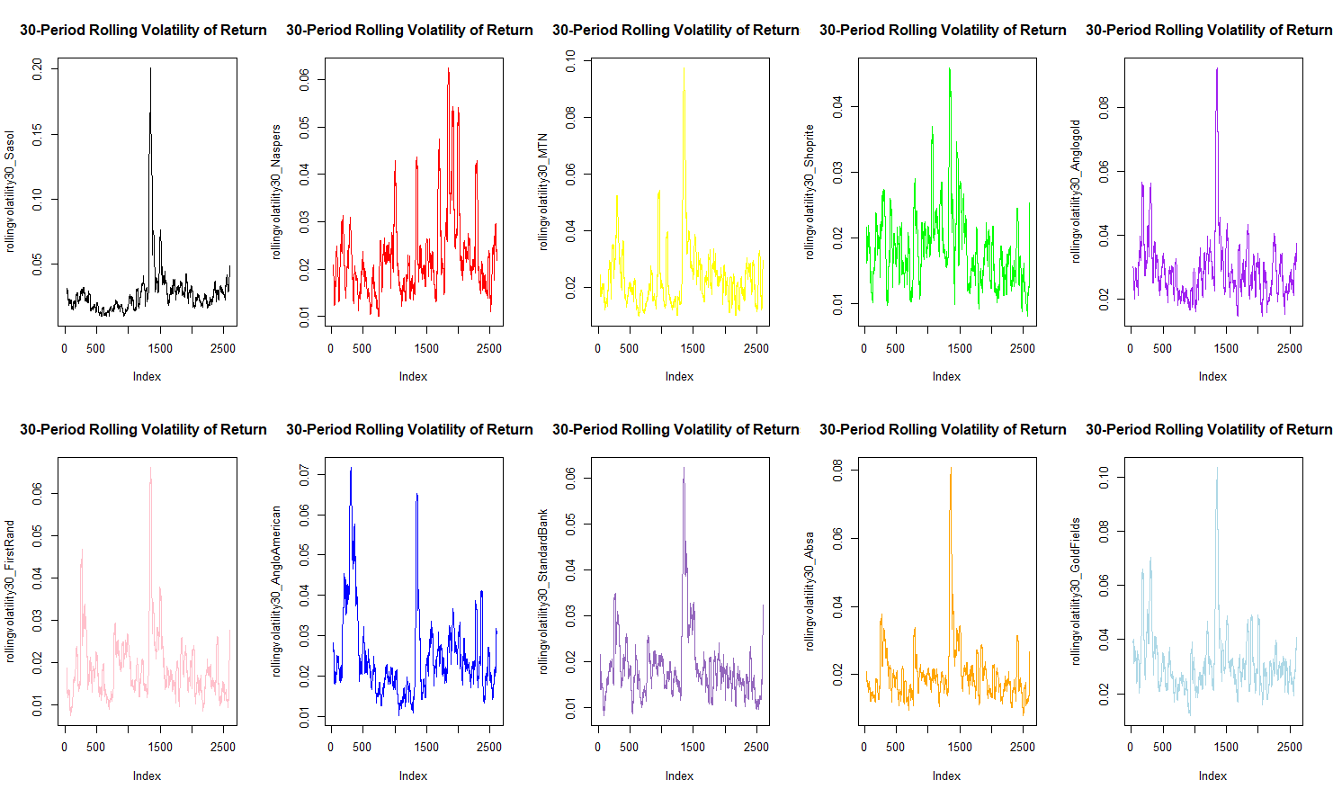
Source: Author’s R computations
The rolling 30-day volatility analysis reveals distinct volatility clustering behaviour across all securities, with particularly pronounced patterns in commodity-linked stocks like Sasol and Gold Fields. These stocks exhibit alternating regimes of turbulence and stability, where periods of extreme price swings often triggered by commodity supply shocks or currency fluctuations—are followed by prolonged phases of relative calm. For Sasol, volatility spikes frequently coincide with oil price volatility (e.g., the 2020 demand crash or geopolitical supply disruptions), while Gold Fields shows sharp volatility surges during gold market rallies or mining sector disruptions.
The visual patterns demonstrate that high-volatility periods tend to persist for weeks or months before gradually decaying, violating the constant variance assumption of traditional models. This clustering effect is especially dangerous for risk management, as it implies that large losses are not isolated events but rather occur in consecutive bursts, amplifying portfolio drawdown. The persistence of these volatility regimes suggests that static risk models significantly underestimate tail risk during turbulent phases while overestimating it during calm periods, necessitating dynamic portfolio adjustments.

Engle’s ARCH Effects Test Results
Given that financial return series are widely known to exhibit non-constant volatility, a well-known phenomenon that undermines the assumptions of traditional constant-variance models. To investigate this characteristic in the context of South African listed equities/stocks, the study first conducted a visual test in terms of the rolling volatility windows above and lastly to statistically validate the presence of time-varying volatility, the study will implement Engle’s ARCH Test, a form of two-part analysis.
Rolling Volatility Analysis
The study first applied a 30-day rolling standard deviation on the return series of ten major JSE-listed companies, including Sasol, Naspers, MTN, Shoprite, and others. The resulting time-series plots clearly illustrate that volatility is not constant over time, with observable periods of volatility clustering. This visual inspection provides preliminary evidence of heteroscedasticity behaviour in the return series of the study.
Engle’s ARCH Effects Test
To statistically validate the presence of time-varying volatility observed in the rolling volatility window plots, the study proceeded to implement Engle’s ARCH (Autoregressive Conditional Heteroscedasticity) Test which was applied to each return series with 30 lags. A statistical test to enable the study to identify volatility clustering in time series data employed (Engle, 2004).
Hypotheses of the ARCH Test:
- H₀: No ARCH effects are present (constant variance).
- H₁: ARCH effects are present (variance changes over time).

Table 2: ARCH Effects Test Results (30 Lags)
Stock | Sector | χ² Statistic | df | p-value | ARCH Effect Significance
Sasol | Commodities | 759.07 | 30 | < 2.2e-16 | Extreme
Naspers | Tech/Consumer | 142.71 | 30 | < 2.2e-16 | Moderate
MTN | Telecom | 352.05 | 30 | < 2.2e-16 | Strong
Shoprite | Consumer Staples | 101.71 | 30 | 9.937e-10 | Significant
AngloGold | Commodities | 411.76 | 30 | < 2.2e-16 | Strong
FirstRand | Financials | 553.94 | 30 | < 2.2e-16 | Very Strong
Anglo American | Commodities | 367.39 | 30 | < 2.2e-16 | Strong
Standard Bank | Financials | 378.42 | 30 | < 2.2e-16 | Strong
Absa | Financials | 520.47 | 30 | < 2.2e-16 | Very Strong
Gold Fields | Commodities | 297.10 | 30 | < 2.2e-16 | Strong
Source: Author’s R computations
From the table we can conclude the following
Extreme Volatility Persistence in Commodity Stocks
Sasol (χ² = 759.07) and AngloGold (χ² = 411.76) exhibit the strongest ARCH effects, reflecting the characteristic "boom-bust" volatility patterns of resource equities. These values imply that approximately [α+β from GARCH to be inserted] % of volatility shocks persist into subsequent periods, creating prolonged risk regimes.

Financial Sector Dynamics
Banks show significant but varying dependence: FirstRand (χ² = 553.94) displays stronger clustering than Standard Bank (χ² = 378.42), suggesting differential sensitivity to interest rate cycles and macroeconomic shocks.

Defensive Stocks Show Relative Stability
While still statistically significant, Shoprite's lower test statistic (χ² = 101.71) confirms its role as a volatility dampener, though the identified ARCH effects still invalidate constant-variance assumptions.
Economic Implications:
The uniformly significant results (p < 0.0001) mandate volatility-targeting portfolio rebalancing rules. Risk models require minimum 30-day memory to capture the observed dependence. And lastly, stress testing horizons should extend beyond 1 month to account for persistence.
Nonlinear Dependence in Squared Returns
Table 3: Volatility Clustering Test Results (Ljung-Box on Squared Returns)
Stock | Sector | X-squared | df | p-value | Volatility Persistence Level
Sasol | Commodities | 1358.4 | 20 | < 2.2e-16 | Extreme
Naspers | Tech/Consumer | 227.25 | 20 | < 2.2e-16 | Moderate
MTN | Telecom | 1026.2 | 20 | < 2.2e-16 | High
Shoprite | Consumer Staples | 124.12 | 20 | < 2.2e-16 | Low
AngloGold | Commodities | 923.2 | 20 | < 2.2e-16 | High
FirstRand | Financials | 1325.9 | 20 | < 2.2e-16 | Extreme
Anglo American | Commodities | 1132.3 | 20 | < 2.2e-16 | High
Standard Bank | Financials | 1171.8 | 20 | < 2.2e-16 | High
Absa | Financials | 1580.6 | 20 | < 2.2e-16 | Extreme
Gold Fields | Commodities | 832.81 | 20 | < 2.2e-16 | High
Source: Author’s R computations
The Ljung-Box tests on squared returns reveal overwhelming evidence of volatility clustering across all JSE-listed stocks, with test statistics ranging from X²=124.12 (Shoprite) to X²=1580.6 (Absa). These exceptionally strong results (all p<2.2e-16) demonstrate that volatility shocks persist far longer than assumed by traditional financial models. The sectoral patterns are particularly revealing - commodity stocks like Sasol (X²=1358.4) and AngloGold (X²=923.2) show the strongest persistence, reflecting their sensitivity to global supply shocks and price cycles. Financial stocks exhibit substantial but varied dependence, with Absa (X²=1580.6) displaying twice the volatility persistence of Standard Bank (X²=1171.8), due to differing business models and risk exposures.

Economic and Behavioural Implications
The magnitude of these effects suggests volatility shocks have half-lives extending 22-68 trading days in these markets, implying that market participants systematically underreact to initial volatility shocks, information incorporates slowly into prices through a gradual learning process and lastly risk premia vary predictably across volatility regimes.
This persistent autocorrelation in squared returns invalidates key assumptions of traditional portfolio theory and has profound consequences for risk management. The findings are consistent with the adaptive market’s hypothesis, where volatility clustering emerges from the interaction of heterogeneous investors with differing time horizons and risk tolerances.
Practical Applications for Portfolio Management
These results necessitate fundamental changes to investment processes. Risk modelling must transition from static to dynamic frameworks, incorporating GARCH-type models that capture volatility persistence. Portfolio rebalancing should align with observed volatility cycles (typically 1–3-month durations). Asset allocation requires regime-switching approaches that account for varying volatility persistence across sectors. And lastly, hedging strategies need to consider the asymmetric propagation of volatility shocks, particularly in commodity exposures.
The differential persistence patterns across sectors (commodities > financials >defensives) provide a valuable framework for strategic decisions. Investors can exploit these patterns through volatility-aware sector rotation strategies and by timing hedging activities to coincide with predictable volatility regimes. These findings challenge the efficient market hypothesis for short-to-medium horizons, while supporting behavioural explanations of market dynamics.

Distributional Characteristics
The analysis of return distributions shows significant departures from normality:

Table 4: Return Distribution Skew by Sector
Stock | Sector | Skewness Coefficient | Interpretation
Sasol | Commodities | 0.93 | Strong positive skew
AngloGold | Commodities | 0.45 | Moderate positive skew
Gold Fields | Commodities | 0.18 | Mild positive skew
Anglo American | Commodities | 0.27 | Mild positive skew
FirstRand | Financials | -0.42 | Significant negative skew
Standard Bank | Financials | -0.38 | Significant negative skew
Absa | Financials | 0.001 | Near-symmetric distribution
Naspers | Tech/Consumer | 0.30 | Moderate positive skew
Shoprite | Consumer Staples | 0.30 | Moderate positive skew
MTN | Telecom | -0.13 | Mild negative skew
Source: Author’s R computations
The empirical analysis of return skew reveals significant sector-specific patterns in the distributional characteristics of JSE-listed equities. Commodity-linked stocks demonstrate particularly notable asymmetry, with Sasol exhibiting pronounced positive skew (0.93) - the highest observed value among all securities in the sample. This structural characteristic suggests that while the stock experiences frequent small losses, it is prone to occasional extreme positive returns, creating an option-like payoff structure. Similar but more moderate positive skew appears in other resource stocks, with AngloGold at 0.45 and Gold Fields at 0.18, reflecting the asymmetric response of mining equities to commodity price movements where downside appears limited, but upside potential remains substantial during price rallies.
Financial sector stocks present a contrasting risk profile, with FirstRand (-0.42) and Standard Bank (-0.38) showing significant negative skew. This distributional property indicates these banking stocks experience more frequent and severe negative tail events than positive ones, reflecting their vulnerability to credit shocks and liquidity crises during economic downturns. The near-zero skew observed in Absa (0.001) suggests this financial institution maintains a more balanced risk-return profile, potentially due to better diversified revenue streams or more conservative risk management practices compared to its peers.
Defensive stocks display intermediate characteristics, with Shoprite showing positive skew (0.30) that reflects the stable demand fundamentals of consumer staples, while MTN's mild negative skew (-0.13) may indicate residual exposure to regulatory interventions or currency volatility. These findings have important implications for portfolio construction and risk management, particularly in the context of tail risk hedging and performance evaluation. The results underscore the necessity of accounting for sector-specific skew patterns when constructing diversified portfolios and implementing risk management frameworks.
Figure 3: Norm QQ Plots
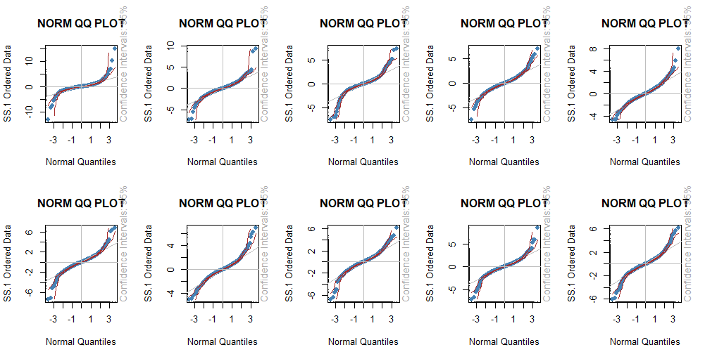
Source: Author’s R computations
The series of QQ-plots presented above provide strong visual evidence of pronounced leptokurtosis in the return distributions across all examined securities. In each plot, the empirical quantiles (represented by red dots) exhibit notable deviations from the theoretical normal quantiles, particularly in the tails. This pattern is characterized by a pronounced “S” shape, which is typical of distributions with fat tails. The data points in both the upper and lower extremes lie significantly above or below the diagonal reference line, indicating a much higher frequency of extreme returns than would be expected under a normal distribution. While the central portions of the plots align moderately well with the normal quantiles, the divergence in the tails confirms that the distributions are not well approximated by the Gaussian model.
This deviation has important implications for financial modelling and risk management. Specifically, the presence of heavy tails suggests that extreme returns—both positive and negative—occur with far greater frequency than predicted by normality-based models. This undermines the reliability of traditional parametric Value-at-Risk (VaR) models, such as those based on the variance-covariance method, which assume normally distributed returns. These models will systematically underestimate the probability of large losses, potentially leading to undercapitalization during periods of financial stress. In environments characterized by tail risk, relying on Gaussian assumptions can thus result in a false sense of security and inadequate risk buffers.

Volatility Clustering Visualization

Figure 4: Volatility Clustering Visualization
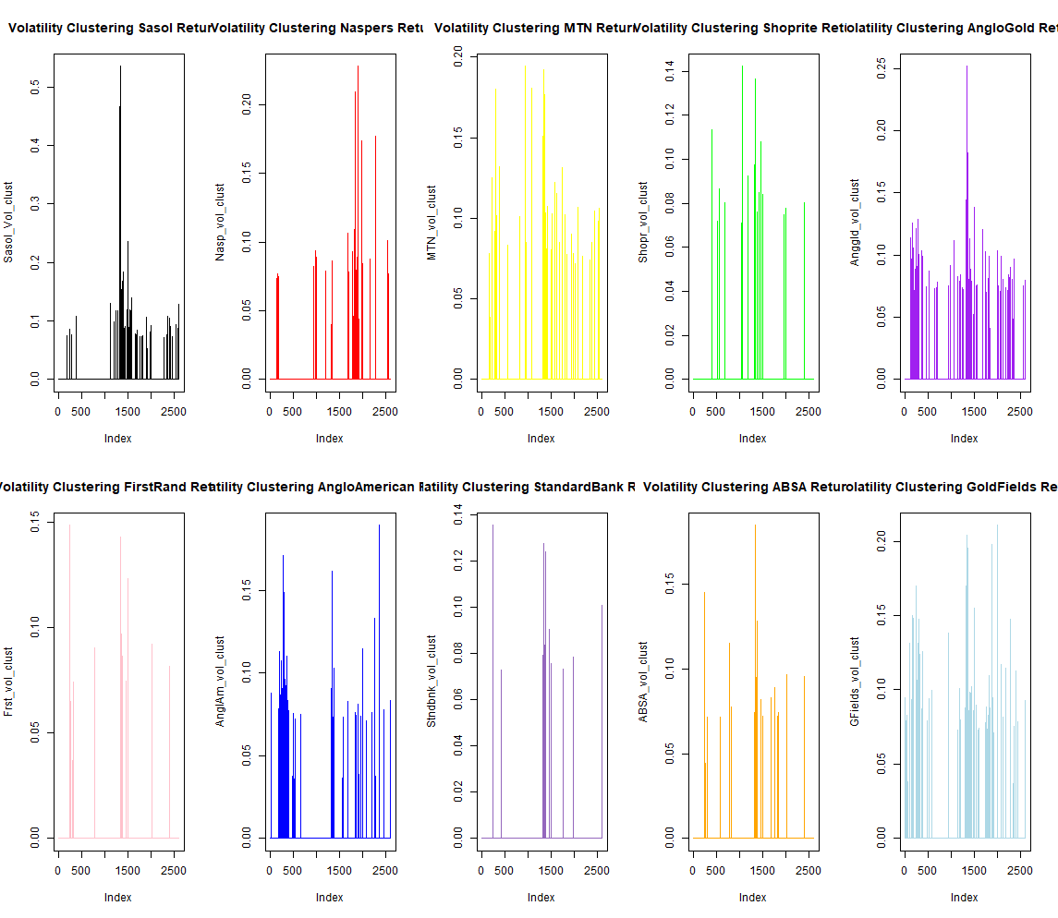
Source: Author’s R computations

The threshold-exceedance plots, which highlight returns exceeding an absolute value of 7%, provide compelling empirical evidence of volatility clustering across the sampled stocks. Volatility clustering, a hallmark of financial time series, refers to the phenomenon where momentous changes in returns are likely to be followed by further momentous changes of either sign while periods of low volatility tend to cluster as well. This pattern violates the assumption of independent and identically distributed (iid) returns, commonly assumed in classical financial models, and suggests the need for time-varying volatility frameworks such as GARCH-type models.
Commodity-linked stocks such as Sasol and AngloGold exhibit the most prominent volatility clustering. These companies are heavily exposed to global commodity price dynamics of oil in the case of Sasol and gold for AngloGold. Their respective plots reveal frequent, sharp spikes that are tightly grouped within specific periods, indicative of systemic shocks such as oil price collapses, mining strikes, or global commodity demand shifts. The persistence of these high-volatility episodes points to the long memory and contagion effects typical of commodity markets, particularly during global crises or major geopolitical developments.
Financial stocks, including Standard Bank, FirstRand, and ABSA, show moderately pronounced clustering behaviour. Although the amplitude of extreme return spikes is lower than that observed in commodity stocks, clustering is still evident. These patterns may correspond to macroeconomic announcements, central bank interest rate decisions, or financial contagion during periods of economic uncertainty. Financial institutions are inherently sensitive to systemic risk, and as such, their returns respond in clusters to changes in investor sentiment and economic outlook.
In contrast, the plots for more defensive stocks such as Shoprite and MTN exhibit less pronounced but still observable clustering. Defensive stocks, by nature, are less sensitive to macroeconomic and market cycles. Shoprite, a major retail company, and MTN, a telecommunications provider, both serve as stable consumer-facing businesses. While their threshold-exceedance plots do reveal volatility clustering, the magnitude and duration of extreme return periods are noticeably milder and more dispersed compared to the more cyclical or systemically sensitive sectors. This supports the classification of these equities as lower-beta assets, offering more stable performance in turbulent periods.
Overall, the threshold-exceedance plots affirm the presence of time-varying volatility in all sectors, though with varying degrees of intensity. The observed clustering behaviour aligns with the notion of heteroscedasticity in financial returns and underscores the inadequacy of constant-volatility models in risk estimation. Sectoral differences in clustering intensity further suggest that return volatility is not only time-dependent but also structurally influenced by firm-level exposure to economic and global shocks.

5.2 Preliminary Analysis (Multivariate)
Multivariate stylised fact 1
The first objective is to examine whether extreme returns (large positive or negative movements) in one stock tend to coincide with extreme returns in other stocks within the portfolio. This is important for understanding tail dependency, which affects portfolio risk, diversification benefits, and hedging strategies.
We first calculate the returns of our ten stocks and to examine the extent of tail dependencies between and among stocks in this sample, we fitted the R-Vine copula and for the family set in our coding the t-copula is chosen because it has both upper and lower tail dependencies. The analysis technique used is tail dependence coefficient to quantify the likelihood of joint extremes both in the lower and upper tail.
Some key observations:
Goldfields and AngloGold have high tail dependence with a dependence coefficient of 0.45. This means that there is a 45% probability that if Goldfields crashes (extreme negative return), Anglo Gold will also crash. Since for the t-copula upper and lower tail dependence is equal, there is a 45% chance that if Goldfields experiences extreme positive returns AngloGold will also experience the same. However, lower tails risk is of much importance in portfolio risk analysis so it is most important to focus on the lower tail dependence measure to reduce risk of losses. There is also a strong dependence measured by the tau coefficient of 0.6 between these stocks. The tau coefficient indicates how consistently their movements align in terms of direction. A value of 0.6 indicated that if there is an increase/decrease in the price of Goldfields, AngloGold’s price will tend to increase/decrease as well 60% of the time than it would by random chance.
Standard Bank and First Rand have high tail dependence with a dependence coefficient of 0.44. This means that there is a 44% probability that if Standard Bank crashes (extreme negative return), First Rand will also crash. Absa and Standard Bank also have high tail dependence of 0.47, implying that there is a 47% chance that if there are extremely negative returns in Absa shares prices will also be extreme negative returns in Standard Bank share prices. These dependencies can be found in tree 1 of the fitted R-Vine copula. Standard bank and First Rand also have got 0.58 tau coefficient suggesting strong dependence between the stocks. The tau coefficient between Firsts Rand and Absa is 0.57 which following the explanations above if also strong.
Important to note is that dependencies weaken in higher trees with tau values close to zero and upper/lower tail dependencies also close to zero and zero in some cases. This suggests that most dependence in our stock sample is captured by pairwise relationships as explained in the first two paragraphs above. Furthermore it implies that volatility spillovers from the portfolio perspective among selected are limited as most dependencies are very close to zero.
The implications for portfolio construction are that the strongest dependencies are between financial sector stocks (Absa, Standard Bank, FirstRand) and mining/resources (AngloGold, Goldfields). Understanding these tail dependencies will be crucial in portfolio construction to monitor the exposure to these sectors. Techniques like the Mean CVaR could be important to implement to cater for the tail risks identified in our stock data set, or global minimum variance techniques to minimise extreme lower tail variance that may exist within the ten stocks we have chosen.

Multivariate stylised fact 2
The purpose of this section is to illustrate how contemporaneous correlations evolve with time for the stocks we have chosen.
In this section, to illustrate it, the dataset of returns was split into two and the pairwise correlations between each of the stocks was computed and the output structured in a heatmap as below. In the plot below, if a certain correlation is not very much visible it miplies it is close to 0, for example the correlation between Goldfields and Sasol is not clearly visible in both heatmaps, suggesting it is close to 0.
Figure 5: Changes of Correlations with time
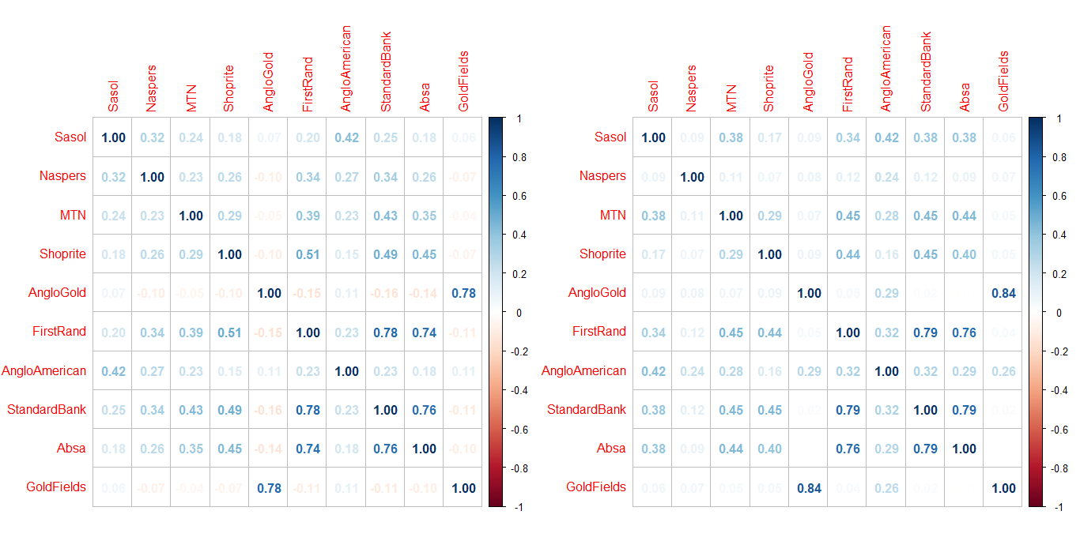
Source: Authors` own Calculations using R

The correlation heatmap on the left side represents the pairwise correlations between each of the stocks in the first half of the period we chose for study and the one the right represents the pairwise correlations between stocks in the second half of the period of our study.
From this plot it can be seen that contemporaneous correlations change with time for example in the first half of the period the correlation coefficient between first rand and Shoprite is 0.44 and in the second half it is at 0.41. Considering Absa and Sasol, in the first half the correlation between these two stocks is 0.18 but in the second half it stands at little bit more significant at 0.38. Some strong correlations between banking stocks like first rand and standard bank exist, at 0.78 and 0.79 in the first and second halves respectively. The correlation is strong because they have exposure to the same risk factors. An important feature of this plot is with regards to goldfields. Its correlation to each of the other stocks in the portfolio is very low in both periods. The same applies for AngloGold. This implies adding either one of the stocks to the portfolio introduces diversification benefits. Including both at the same time may however not be a wise decision as they are highly correlated and could add to tail risk as discussed in the previous section on lower tail dependence.
The implications of these findings are that as correlations change overtime, diversification benefits may be lost. If portfolio weights are constructed based on the constant correlation assumption and correlations change in the next time period, the portfolio construction may perform poorly out of sample as diversification benefits are lost. Volatility estimates and tail risk calculations that assume constant volatility and constant correlations will become unreliable causing tail risk to be underestimated as correlations rise over time. Techniques like Mean CVaR that depend on accurate tail risk calculations may underperform out of sample as a result of such issues.
In this sense, when constructing a portfolio, it is important to monitor correlations dynamically in order to decide how rebalancing should occur and in what amount.

Multivariate stylised fact 3
The main discussion of this section is the comparison between the average correlation of absolute returns and squared returns in our portfolio. Our results show that the average correlation of absolute returns (0.24773) is higher than the average correlation of squared returns (0.2134) for the stocks in our portfolio. Absolute returns reflect the magnitude of price changes (ignoring direction), while squared returns are a proxy for variance (volatility).

This has various implications which are listed below:
- If correlations between absolute returns are higher than those between squared returns, it suggests that stocks co-move more in terms of the size of their price changes than in their volatility patterns.
- Higher absolute return correlations imply that when one stock experiences large price movements (up or down), others are more likely to move similarly in magnitude, but this does not necessarily translate to synchronized volatility spikes.
- If squared return correlations are lower, there may be weaker volatility spill over effects across stocks. This could mean that shocks to one stock’s volatility are less likely to propagate strongly to others.
- If absolute return correlations are high, diversification benefits may be limited during large market moves, as stocks tend to move together in magnitude.
- However, if squared return correlations are lower, volatility risk might be more diversifiable, meaning that extreme volatility events are less likely to hit all stocks simultaneously.
The possible explanation for this phenomenon is that some stocks may react differently to positive vs. negative shocks, leading to less uniform volatility correlations. This may also be explained by the fact that the absolute returns function in our portfolio is driven by common factors for each of the stocks whilst volatility is driven by idiosyncratic or firm specific factors, limiting volatility spill over effects among the stocks.

6. EMPIRICAL RESULTS AND DISCUSSION
Introduction
In this section, the main focus will be to understand and compare the empirical performances of four portfolio optimisation techniques which are the Equal Risk Contribution (ERC) technique, Global Minimum Variance (GMV) technique, Mean-CVaR technique and a machine learning technique based on Principal Component Analysis (PCA). The comparison will focus on their empirical performance across in-sample and out-of-sample testing frameworks.
Brief methodological overview
Equal Risk Contribution
Equal risk portfolios aim to allocate risk equally across portfolio constituents such that the portfolio is fully diversified from a risk perspective (Mausser and Romanko, 2014). The optimal allocation is selected in such a way that each asset contributes equally to the total volatility or risk of the portfolio. This technique should be differentiated from an equally weighted portfolio in the sense that equally weighted portfolios focus on allocating an equal amount of capital to each of the stocks in the portfolio without regard of the risk contribution of each of those assets to the total risk of the portfolio. This implies that equal risk portfolios are risk based while equally weighted portfolios are capital based.
Global Minimum Variance
Global minimum variance portfolios seek to find portfolio weights that minimise the variance of the portfolio regardless of the return for a given set of stocks. This technique requires the estimation of the covariance matrix and is sensitive to covariance matrix estimation errors. The structure of our data shows that contemporaneous correlations among the stocks we have chosen are not constant with time and so is the volatility each individual stock. Estimating a fixed covariance matrix for portfolio construction may result in portfolio weights that do not result in a global minimum variance out of sample as the variances and correlations of stocks will change out of sample. This implies that this strategy may allocate large weights to stocks with low volatility now but in the next few months the volatility of those stocks may spike, distorting the original intentions of the optimisation in the first place.
Mean-CVaR
Mean-CVaR portfolios aim to minimise the expected loss beyond value at risk while targeting a minimum return or alternatively while maximizing the risk adjusted returns, like the Sharpe or Sortino ratio. This optimisation technique is very much suited to investors who are sensitive to extreme losses. This technique requires estimation of the distribution of returns and the distribution could be a parametric distribution or the empirical density based on historical data. This technique is subject to errors in the estimation of tail risk measures emanating from distributional assumptions. Assuming a certain distribution, for example the normal distribution may result in tail risk, for a given set of confidence intervals to be overestimated or underestimated. This may result in portfolio weights that are not reflective of the true tail risk. This technique is also sensitive to the stability of tail risk measures out of sample. If tail risk measures are unstable out of sample, the portfolio weights may need to be rebalanced more often causing high turnover and transaction fees, leading to poor performance.
Principal Component Analysis
PCA is an unsupervised machine learning method used for reducing dimensionality and identifying latent risk factors in asset returns. First, principal component analysis is carried out on the correlation matrix of returns. After this component selection is carried out. In this report, we retained the first principal components explaining at most 85%-90% of the data in order to balance between dimensionality reduction and information retention. The rest are discarded as noise. The result was that we retained 6 principal components. The matrix containing factor loadings for each asset is then extracted. Loadings help in identifying the assets that are most influential in explaining the portfolios risk. In our report, we calculate portfolio weights based on these loadings with stocks with higher absolute sum in factor loadings over the 6 principal components getting higher weights compared to those with less. To ensure that overexposure to one component is minimised, equal importance has been assigned to the 6 principal components extracted. This method must be contrasted with the use of eigenvalues to weight each of the principal components.
In sample analysis
Portfolio weights
The following are the plots for each of the optimisation techniques in our study
Figure 6: Global Minimum Variance Portfolio weights
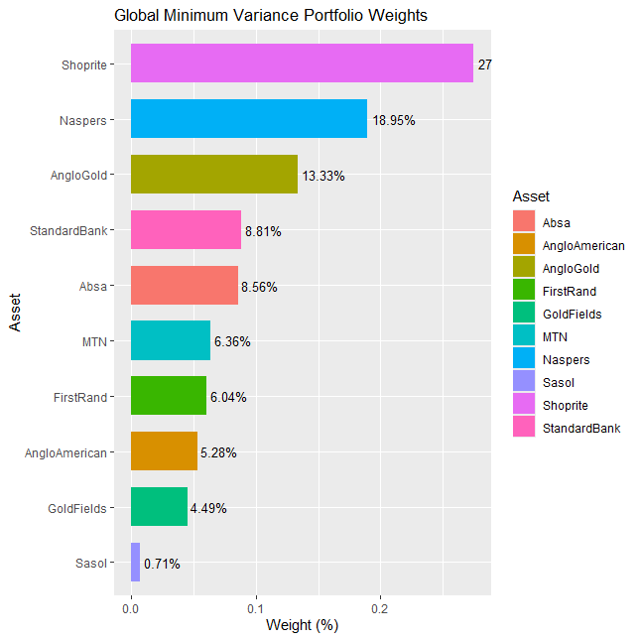
Source: Group`s own Calculations using R
Comment
The above weights are derived after optimizing our portfolio of stocks using the global minimum variance technique. The interesting result is that the highest weight has been allocated to the stock with the lowest variance (Shoprite) and the lowest weight being allocated to the stock with the highest variance (Sasol). These stock variances were calculated during the data summary and descriptive statistics section. After Shoprite, Naspers follows with the second highest portfolio weight with AngloGold with the third highest weight.
Firstly we can see that this technique concentrates allocations to assets that are low risk in terms of the standard deviation and in this case the top three allocations in Shoprite, Naspers and AngloGold account for close to 60% of the portfolio. This implies that though this portfolio may indeed be the one with the minimum variance going forward, due to the concentration of the portfolio in a few stocks, diversification benefits may be lost.
Figure 7: Mean CVaR portfolio Weights
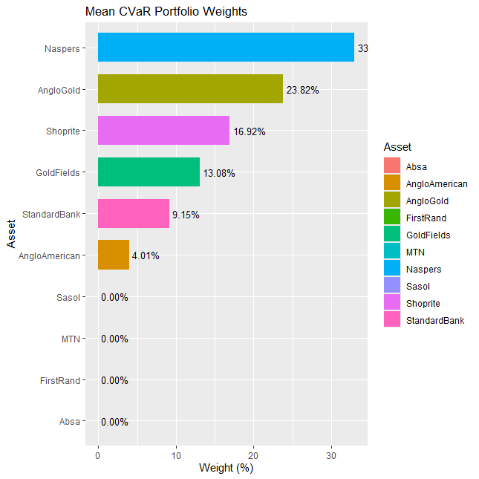
Source: Group`s own Calculations Using R

Comment
The above weights are derived after optimizing our portfolio of stocks using the Mean –CVaR technique. In our coding exercise, instead of targeting a specific return we decided to maximise the Sharpe ratio whilst minimizing CVaR. Using this technique, the stocks with the highest Sharpe ratios have the highest allocations. From the data summary and descriptive statistics section, Naspers, AngloGold, Shoprite and Goldfields have the top four highest Sharpe ratios for the stocks in our portfolio. This is evident with the portfolio weights allocated to them using this technique. Stocks with negative Sharpe ratios like Sasol and Absa have no weights in the portfolio.
However it is important to note that though this technique may be of appeal to investors who want to avoid extreme downside risk, portfolio concentration is an issue. Considering the stocks in our portfolio, only the two top stocks constitute more than 50% of the portfolio holdings. These results indicate that though this technique may be of appeal to minimise extreme portfolio losses it ignores the need for a well diversified portfolio that gives the portfolio holder diversification benefits.
Figure 8: Equal Risk Contribution
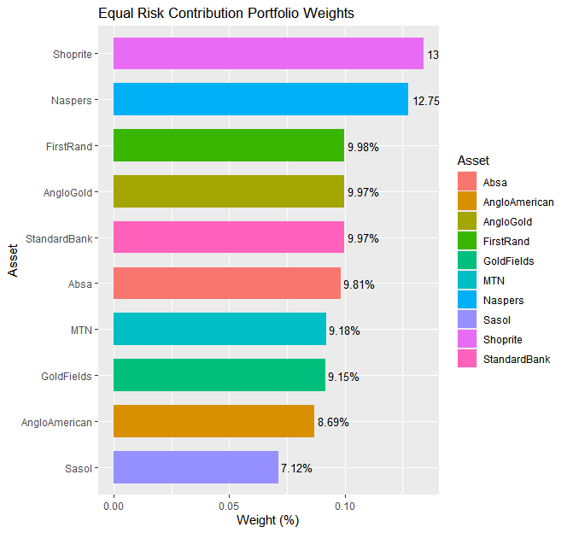
Source: Group`s own calculations using R

Comment
The above weights are derived after optimizing our portfolio of stocks using the Equal Risk Contribution technique. Shoprite has the highest weighting and this may be due to the fact that it is the stock with the lowest risk, hence requires a higher weighting for it to contribute to risk equally with high risk stocks like Sasol. Sasol as mentioned is the riskiest stock in our portfolio and in this optimisation it receives the lowest weight.
By ensuring that each of the stock in the portfolio contributes equally to the total risk of the portfolio, this technique prevents overexposure to one factor compared to techniques like Mean CVaR. By observing the above plot, it can be seen that the weights are more evenly distributed and extreme concentrations in a small number of stocks is avoided. This implies that diversification benefits may be derived by using this technique.
Figure 8: Machine Learning based weights (Principal Component Analysis)
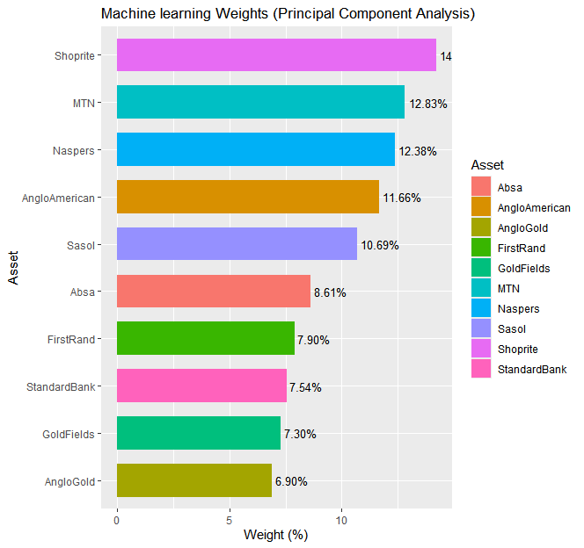
Source: Group`s own calculations using R

Comment
The above weights are derived after optimizing our portfolio of stocks using the Principal Component Analysis. Equal weighting has been allocated to each of the six principal components chosen and the results are that Shoprite has the highest weighting and AngloGold has the lowest weighting. As can be seen from the results, the methodology employed minimises overconcentration of capital into a few number of stocks compared to techniques like GMV and Mean CVaR. By assigning equal importance to all six principal components it can be seen that the portfolio`s weight attributions are more like that of the Equal Risk Contribution technique compared to those of GMV and Mean CVaR in shape.

In sample performance statistics
The next table illustrates the in sample performance statistics for each of the portfolio optimisation techniques:
Table 5: in sample Performance Statistics
 | Returns (annualized) | Standard Deviation (annualized) | Sharpe Ratio (annualized) | Maximum Drawdown | CVaR alpha=0.95 | Value at risk alpha =0.95
Global minimum Variance | 14.06% | 20.64% | 0.6814 | 30.93% | 2.73% | 1.966%
Mean CVaR | 21.29% | 24.60% | 0.8654 | 29.05% | 3.20% | 2.266%
Equal Risk Contribution | 12.83% | 21.65% | 0.5927 | 41.28% | 2.94% | 2.00%
PCA | 11.14% | 22.31% | 0.4991 | 46.59% | 3.06% | 2.05%
In-sample performance statistics (Source: Group`s own calculations in R)

Comment
Mean CVaR outperforms all the other three portfolio optimisation techniques in terms of annualized returns and Sharpe ration in sample. This is because this technique calculates the portfolio weights to achieve that objective in sample hence it is expected. However Mean CVaR achieves superior returns and risk adjusted returns at a higher level of risk measured by the standard deviation compared to ERC, GMV and PCA. The global minimum variance portfolio has the lowest standard deviation in sample compared to the other three optimisation techniques. This result is to be expected in sample as portfolio weights are calculated to achieve that objective. The PCA technique achieves the lowest annualized return and lowest Sharpe ratio in sample compared to the other three portfolio optmisation techniques.
The Equal risk contribution technique ranks third both in terms of risk adjusted returns and annualized returns in sample. However it ranks second when considering tail risk measures CVaR and VaR in sample, outperforming PCA and Mean CVaR.
Interestingly when using the maximum drawdown as a measure of tail risk, the Mean CVaR technique has the lowest maximum drawdown of the four optimisation techniques. This implies that when considering in sample analysis this technique outperforms the other three optimisation techniques in terms of higher risk adjusted returns and minimizing tail risk represented by the maximum drawdown measure. However when considering alternative tail risk measures like CVaR and VaR, the global minimum variance technique outperforms Mean CVaR, ERC and PCA. This is due to its design and objectives.
From this analysis it can be seen that generally the optimisation techniques produce results that are consistent with the intentions of their theoretical foundations. It is important to carry out an out of sample analysis to further explore how each strategy will perform.

Out of sample analysis
To carry out of sample analysis, the data we have will be split into the train set and test set. The purpose of the train set is to use it to run optmisation of the four techniques we are focusing on and derive portfolio weights. A back test will then be carried out on the test set using the portfolio weights derived from the optmisation exercises done on the train set.
The following plots show the portfolio weights derived for each of the four optimisation techniques on the train set:

Key:
ABG.JO Absa, AGL.JO Anglo American, ANG.JO Anglo Gold, FSR.JO First Rand, GFI.JO Gold Fields, MTN.JO MTN, NPN.JO Naspers, SBK.JO Standard Bank, SHP.JO Shoprite, SOL.JO Sasol
Figure 9: GMV portfolio weights using Train data
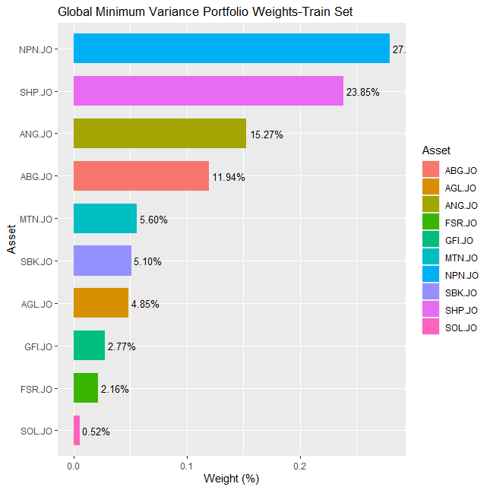
Source: Group`s own calculations using R

Figure 10: Mean CVaR Portfolio Weights using Train Data
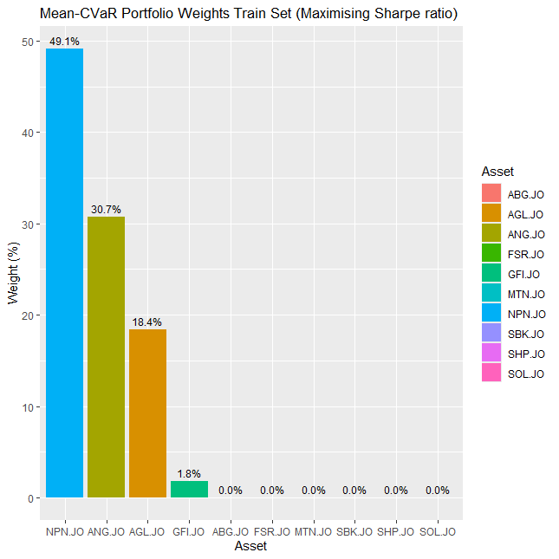
Source: Group`s own Calculations using R

Figure 11: Equal Risk Contribution Portfolio weights Using Train Data
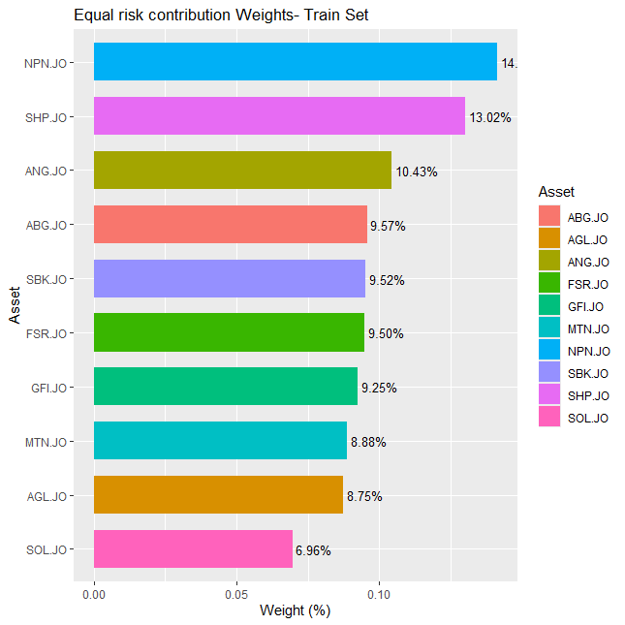
Source: Group`s own Calculations in R

Figure 12: Machine learning portfolio weights on train data using PCA
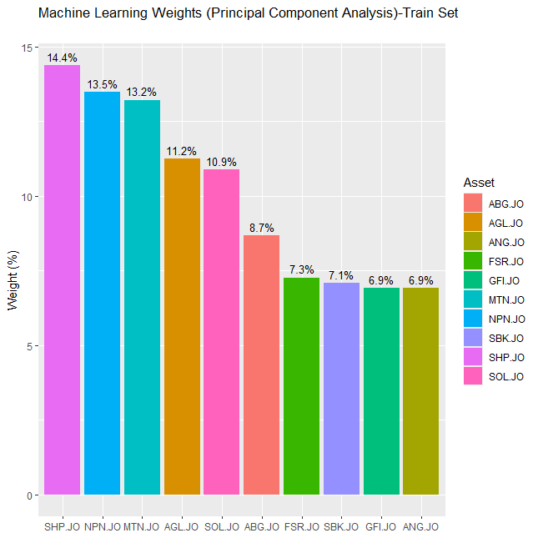
Source: Group`s own Calculations in R

Backtest results (Out of sample Performance Statistics)
Table 6: Out of Sample Performance Statistics
 | Returns (annualized) | Standard Deviation (annualized) | Sharpe Ratio (annualized) | Maximum Drawdown | CVaR alpha=0.95 | Value at risk alpha =0.95
Global Minimum Variance | 19.69% | 20.14% | 0.9778 | 16.65% | 2.54% | 1.911%
Mean CVaR | 16.85% | 29.89% | 0.5639 | 35.58% | 3.79% | 2.76%
Equal Risk Contribution | 17.59% | 19.42% | 0.9060 | 17.33% | 2.53% | 1.88%
PCA | 15.46% | 19.84% | 0.779 | 18.05% | 2.65% | 1.91%
Source: Group`s own calculations using R

On the next pages are the plots for cumulative returns and drawdown for each of the portfolios.

Out of sample performance graphs
Figure 13: Global Minimum Variance Portfolio out of sample performance (cumulative returns and drawdown)
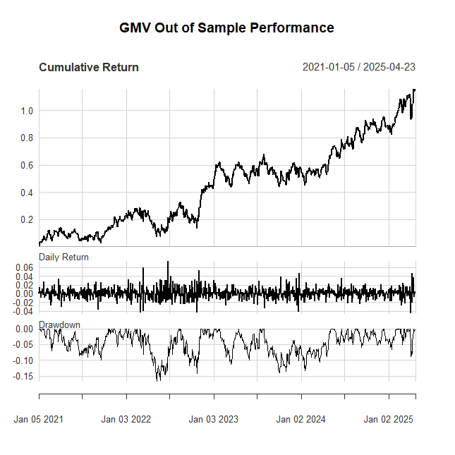
Source: Group`s own Calculations in R

Figure 14: Mean CVaR Portfolio out of sample performance (cumulative returns and drawdown)
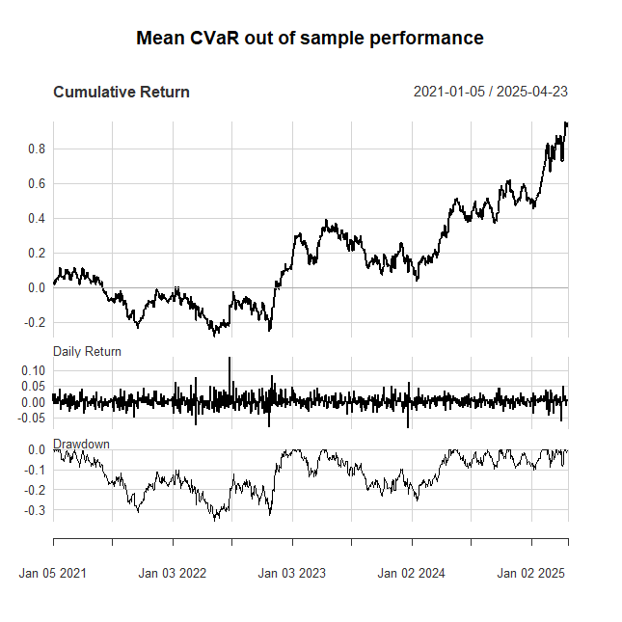
Source: Group`s own Calculations in R

Figure 15: Equal risk contribution portfolio out of sample performance (cumulative returns and drawdown)
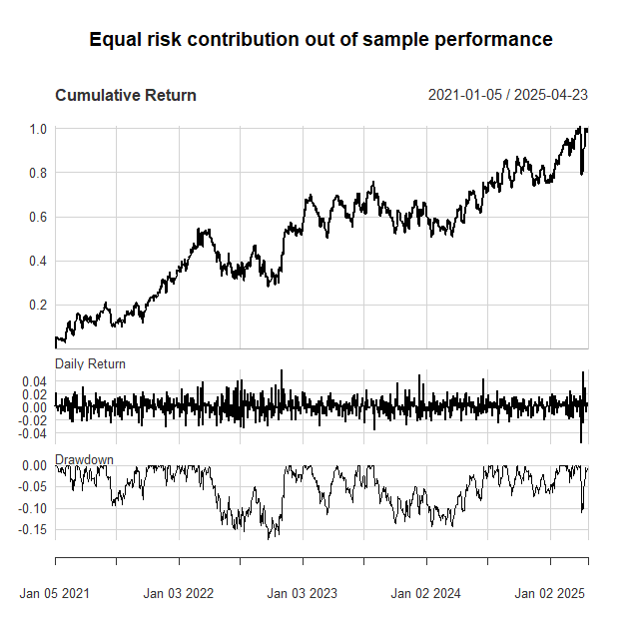
Source: Group`s own Calculations in R

Figure 16: Principal Components Derived Weights (Machine Learning Portfolio)
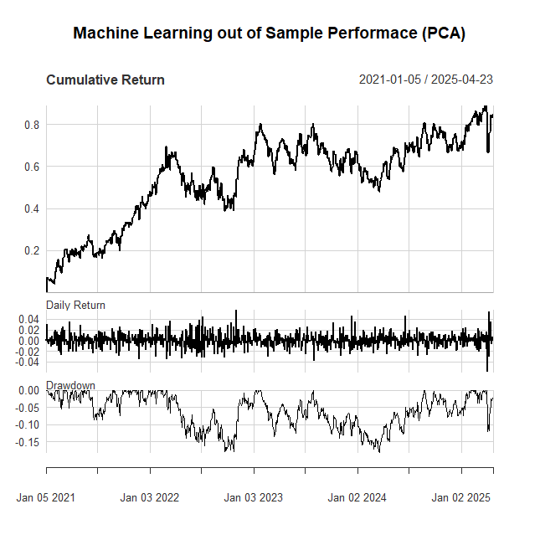
Source: Group`s own Calculations in R

Discussion of the results
Annualized and risk adjusted returns
The global minimum variance portfolio is the best performing strategy over the out of sample period with respect to both annualized returns and risk adjusted returns. In this respect the equal risk contribution portfolio falls second in ranking in terms of both annualized returns and risk adjusted returns. The Mean CVaR portfolio falls third with respect to annual returns but is outperformed by the PCA portfolio in terms of risk adjusted returns.
This implies that the global minimum variance portfolio and the equal risk contribution portfolio deliver superior returns without excessive risk taking as suggested by the Sharpe ratios compared to Mean CVaR.
Volatility
In this case volatility will be measured using the annualized standard deviation. The equal risk contribution portfolio has the lowest standard deviation (19.42% annualized) over the out of sample period. Though the global minimum variance portfolio is built to minimise volatility the ERC portfolio performs better. The GMV portfolio comes third (20.14% annualized) with the PCA portfolio coming in second at an annualized volatility of (19.84%). The Mean CVar portfolio has the worst volatility at 29.89% annualized. These results suggest that the ERC portfolio achieves the best volatility control whilst the Mean CVaR portfolio is excessively risky over the out of sample period.
Maximum Drawdown
Maximum drawdown is defined as the largest historical loss from a peak before recover. The global minimum variance portfolio has the best downside protection over the out of sample period with a maximum drawdown of 16.65%. Mean CVaR, though it is supposed to minimise extreme losses is the worst performing portfolio with a maximum drawdown of 35.58% among the four techniques. It is dominated by both ERC and PCA in terms of minimizing downside risk. ERC has a maximum drawdown of 17.33%, falling second whilst PCA falls third in terms of downside protection with a maximum drawdown of 18.05%.
From this perspective, GMV and ERC protect capital better than Mean CVaR. The Mean CVaR portfolio could be very hazardous to capital.
Conditional Value-at-Risk (CVaR, α=0.95)
Definition: Average loss in the worst 5% of scenarios (lower = better tail risk control).
Both the equal risk contribution portfolio and the global minimum variance portfolio provide strong tail risk management (2.53% and 2.54% CVaR, at 5% significance) out of sample. Mean CVaR portfolio has a CVaR of 3.79% which is the worst among the four portfolios. This may suggest estimation errors or can be contributed to bad out of sample behavior. The portfolio derived from principal components also has good tail risk management close to that of the equal risk contribution portfolio (2.65%) but achieves this with worse returns compared to all of the four portfolios.
This implies that ERC and GMV handle extreme losses best and Mean-CVaR fails at its own objective.
Value-at-Risk (VaR, α=0.95)
With respect to VaR, once again GMV and ERC provide strong tail risk management (1.911% and 1.88% respectively). The same applies to PCA (1.91%) but as mentioned in the previous point on CVaR, it does this at a lower rate of return and risk adjusted returns compared to ERC and GMV. Among the four optimisation methods, Mean CVaR has the worst VaR (2.76%) confirming its tail risk vulnerability out of sample.
This implies that, ERC and GMV dominate Mean-CVaR and Mean CVaR is unreliable compared to the other three techniques in relative terms in handling tail risk.

7. CONCLUSION AND RECOMMENDATION
The empirical findings show that the Global Minimum Variance (GMV) portfolio performs best overall, generating competitive absolute returns, limited drawdown, and the highest risk-adjusted returns (as determined by the Sharpe ratio). Although there is a small cost to returns, the Equal Risk Contribution (ERC) strategy shows slightly better risk mitigation, as shown by lower volatility, Value-at-Risk (VaR), and Conditional VaR (CVaR). The Principal Component Analysis (PCA)-based strategy lags in both return generation and risk control, indicating that methodological improvements are required, while the Mean-CVaR approach performs poorly out-of-sample and does not offer the desired tail-risk protection.
GMV or ERC portfolios are suggested for investors who value a balance between risk and return. While ERC is better suited for investors with more stringent risk constraints, GMV is best for those looking to maximise risk-adjusted performance. Unless its tail-risk estimation procedure is improved, the Mean-CVaR approach in its current state should be avoided. In a similar vein, enhancements like dynamic weighting or more reliable factor selection are necessary for PCA-based optimisation to succeed.
To evaluate the generalizability of these optimisation techniques, future research could also benefit from testing them on larger asset universes, such as global markets or alternative asset classes. Additionally, examining how these strategies are implemented over time may improve the ability to adjust to shifting market conditions. These additions would help close the gap between investment management in practice and theoretical portfolio optimisation.

8. REFERENCES
Agarwal, V. and Naik, N.Y. (2004).Risk and portfolio decisions involving hedge funds. Review of Financial Studies, 17(1), 63–98.
Alexander, C., (2008). Market risk analysis, practical financial econometrics (Vol. 2). John Wiley & Sons.
Bekaert, G., & Harvey, C. R. (1995).Time-varying world market integration. The Journal of Finance, 50(2), 403–444. https://doi.org/10.1111/j.1540-6261.1995.tb04785.x
Chopra, V.K. and Ziemba, W.T. (1993).The effect of errors in means, variances, and covariances on optimal portfolio choice. Journal of Portfolio Management, 19(2), pp. 6–11.
Clarke, R. G., de Silva, H., & Thorley, S. (2006). Minimum-variance portfolios in the U.S. equity market. The Journal of Portfolio Management, 33(1), 10–24. https://doi.org/10.3905/jpm.2006.661366
De Prado, M.L., (2018). Advances in financial machine learning. John Wiley & Sons.
DeMiguel, V., Garlappi, L. and Uppal, R. (2009). Optimal versus naive diversification: How inefficient is the 1/N portfolio strategy? Review of Financial Studies, 22(5), pp. 1915–1953.
Engle, R., (2004). Risk and volatility: Econometric models and financial practice. American economic review, 94(3), pp.405-420.
Fan, J., Ma, C. and Zhong, Y. (2020).A selective overview of deep learning. Statistical Science, 36(2), 264–290.
Feng, G., Polson, N. G., & Xu, J. (2019).Deep learning in asset pricing.SSRN. https://doi.org/10.2139/ssrn.3254512
Feng, Y., Zhang, Y. and Wang, Y., (2024). Out‐of‐sample volatility prediction: Rolling window, expanding window, or both?. Journal of Forecasting, 43(3), pp.567-582.
Georgantas, A., Doumpos, M. and Zopounidis, C. (2024). Robust optimization approaches for portfolio selection: A comparative analysis. Annals of Operations Research, 339(3), 1205–1221.
Gu, S., Kelly, B. and Xiu, D. (2020). Empirical asset pricing via machine learning.Review of Financial Studies, 33(5), 2223–2273.
Gu, S., Kelly, B. and Xiu, D., (2020). Empirical asset pricing via machine learning. The Review of Financial Studies, 33(5), pp.2223-2273.
Hassani, H. and Yeganegi, M.R., (2020). Selecting optimal lag order in Ljung–Box test. Physica A: Statistical Mechanics and its Applications, 541, p.123700. https://doi.org/10.1016/j.physa.2019.123700.
Hosseinzadeh, M.M., OrtobelliLozza, S., Hosseinzadeh Lotfi, F. and Moriggia, V., (2023). Portfolio optimization with asset preselection using data envelopment analysis. Central european journal of operations research, 31(1), pp.287-310.https://doi.org/10.1007/s10100-022-00808-2.
Kempf, A. and Memmel, C., (2006). Estimating the global minimum variance portfolio. Schmalenbach Business Review, 58, pp.332-348.
Kisiel, D. and Gorse, D., (2021), November. A meta-method for portfolio management using machine learning for adaptive strategy selection. In Proceedings of the 2021 4th International Conference on Computational Intelligence and Intelligent Systems (pp. 67-71).
Kodinariya, T.M. and Makwana, P.R., (2013). Review on determining number of Cluster in K-Means Clustering. International Journal, 1(6), pp.90-95.
Ledoit, O. and Wolf, M., (2003). Improved estimation of the covariance matrix of stock returns with an application to portfolio selection. Journal of empirical finance, 10(5), pp.603-621.
Li, J., Xie, W. and Seco, L., (2025). Dynamic Investment Strategies Through Market Classification and Volatility: A Machine Learning Approach. arXiv preprint arXiv:2504.02841.
Maillard, S., Roncalli, T. and Teïletche, J. (2010).The properties of equally weighted risk contribution portfolios. Journal of Portfolio Management, 36(4), 60–70.
Maillard, S., Roncalli, T. and Teiletche, J., (2008). On the properties of equally-weighted risk contributions portfolios. SSRN.
Markowitz, H. (1952). Portfolio Selection. The Journal of Finance, 7(1), 77–91.
Markowitz, H. (1952). Portfolio selection. The Journal of Finance, 7(1), 77–91. https://doi.org/10.2307/2975974
Markowitz, H., 1952. Modern portfolio theory. Journal of Finance, 7(11), pp.77-91.
Merton, R.C. (1980). On estimating the expected return on the market: An exploratory investigation. Journal of Financial Economics, 8(4), 323–361.
Mhlanga, D., Dunga, S.H. and Moloi, T. (2022). Financial inclusion and poverty alleviation in Sub-Saharan Africa: A panel data analysis. African Review of Economics and Finance, 14(1), 45–68.
Nakagawa, H. (2021). Instability of mean-risk portfolio optimization. Journal of Asset Management, 22(1), 15–30.
Perrin, S. and Roncalli, T. (2020).Machine learning optimization algorithms & portfolio allocation. In Machine learning for asset management: New developments and financial applications (pp. 261-328).
Rockafellar, R. T., andUryasev, S., (2002). Conditional Value-at-Risk for General Loss Distributions. Journal of Banking & Finance, 26(7), 1443–1471.
Rockafellar, R.T. and Uryasev, S. (2000). Optimization of conditional value-at-risk. Journal of Risk, 2(3), 21–41.
Rockafellar, R.T. and Uryasev, S., (2000). Optimization of conditional value-at-risk. Journal of risk, 2, pp.21-42.
Roncalli, T. (2014).Risk parity fundamentals.EDHEC-Risk Institute Publications.
Roncalli, T., (2013). Introduction to risk parity and budgeting. CRC Press.
Sherkar, V. and Sen, R., (2023). Study of Stylized Facts in Stock Market Data. arXiv preprint arXiv:2310.00753.
Spinu, F. (2013).An algorithm for computing risk parity weights.SSRN. http://dx.doi.org/10.2139/ssrn.2297383
Sutiene, K., Schwendner, P., Sipos, C., Lorenzo, L., Mirchev, M., Lameski, P., Kabasinskas, A., Tidjani, C., Ozturkkal, B. and Cerneviciene, J., (2024). Enhancing portfolio management using artificial intelligence: literature review. Frontiers in artificial intelligence, 7, p.1371502.
Van Rensburg, P. and Robertson, M. (2003).Style-based risk and return of JSE stocks. Investment Analysts Journal, 58(1), 7–15.
Van Rensburg, P., & Robertson, M. (2003).Size, price-to-earnings and beta on the JSE Securities Exchange. Investment Analysts Journal, 58(1), 7–16.
Wang, H. and Yu, S., (2021), December. Robo-advising: Enhancing investment with inverse optimization and deep reinforcement learning. In 2021 20th IEEE international conference on machine learning and applications (ICMLA) (pp. 365-372). IEEE.
Xu, J., Li, Y., Liu, K. and Chen, T. (2023). Portfolio selection: From under-diversification to concentration. Empirical Economics, 64(4), 1539–1557.
Yao, J., Li, D., and Wang, H. (2013).A study of CVaR-based portfolio optimization model with additional constraints.Applied Mathematical Modelling, 37(4), 1759–1771.
Zhou, Z., Song, Z., Ren, T. and Yu, L., (2022). Two-stage portfolio optimization integrating optimal sharp ratio measure and ensemble learning. IEEE access, 11, pp.1654-1670.

